Create an S3 bucket and upload some objects to S3.
Create the S3 bucket
Name the S3, unique
Let asl (disable)
Uncheck the Block all public
Create
Upload the any file
Give the ASL as Make public
Copy the the link and try on browser, done
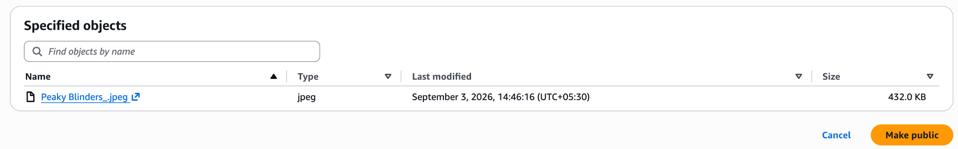
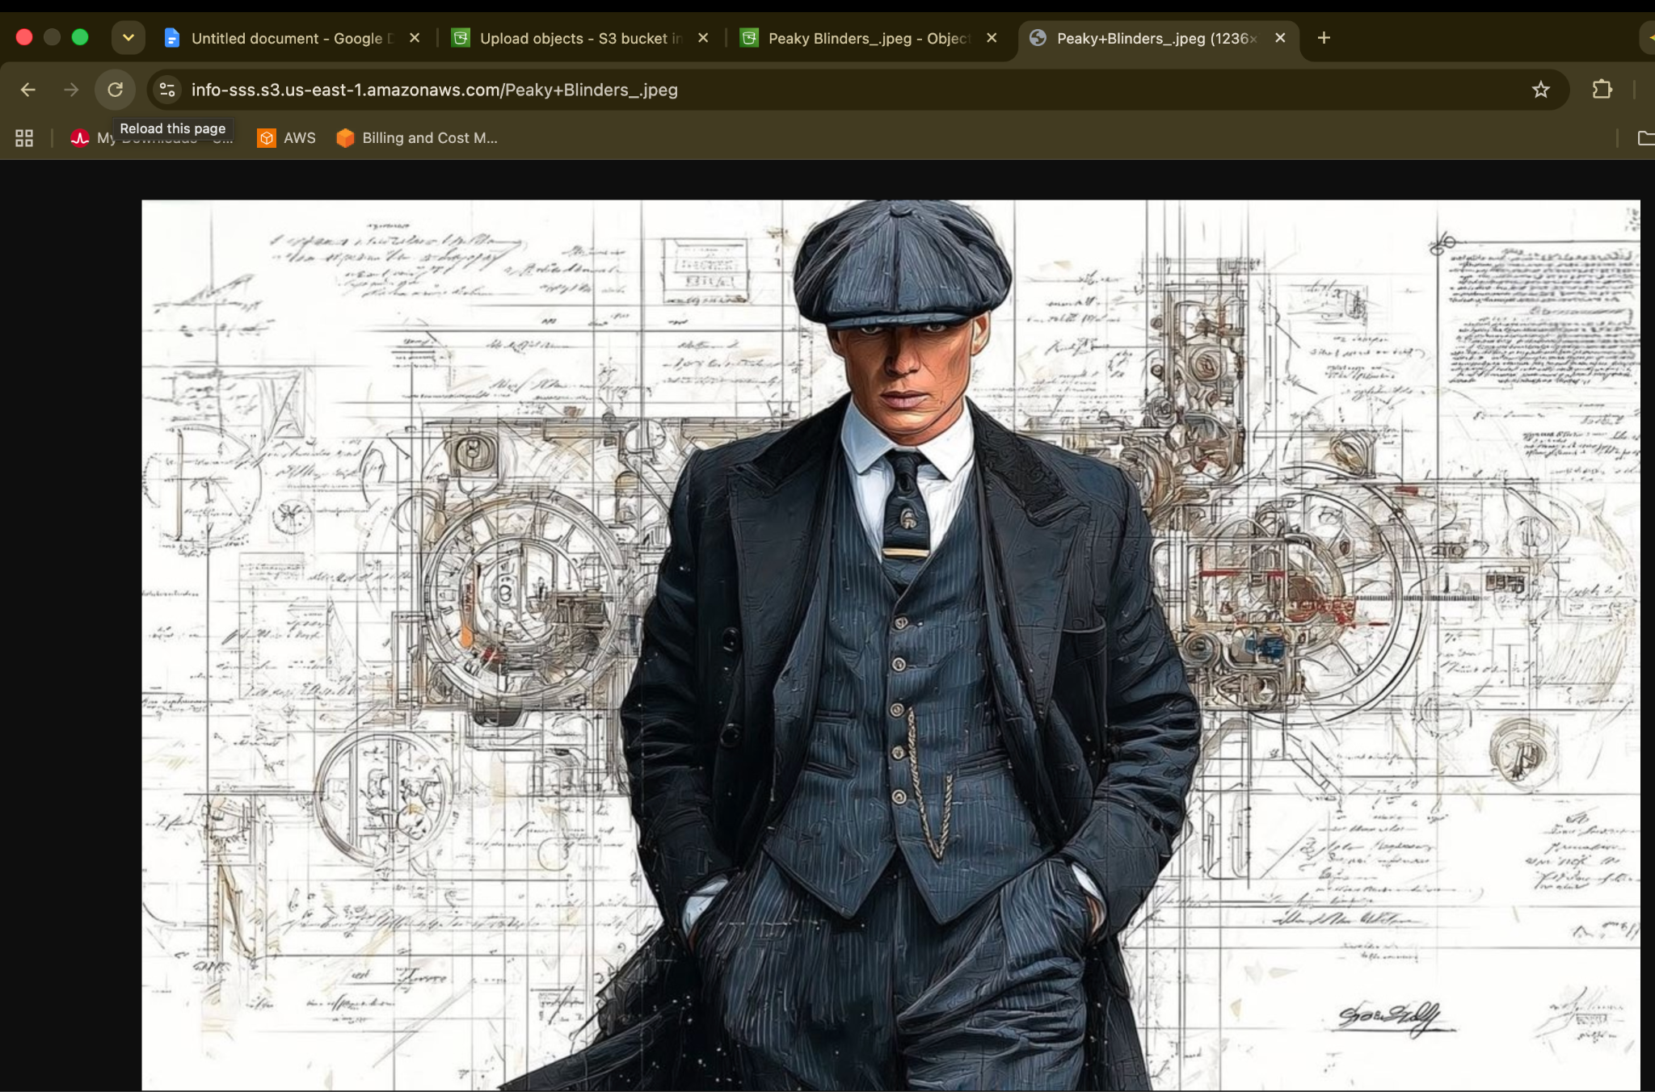

Deploy a static website in the S3 bucket.
Create a index.html, error.html
Go to you s3→upload→index.html&error.html
Go to properties→scrolldown→static webpage→
It should match with same name index.html&error.html→save changes
properties→scrolldown→static webpage→copy the link and Browse done in order to see the error.html remove index.html.
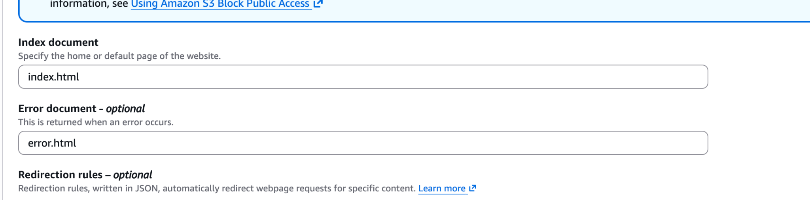
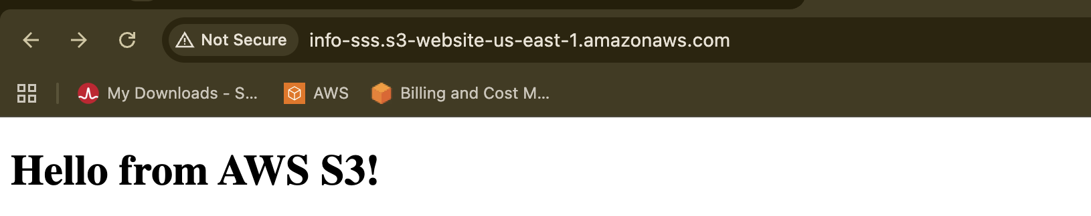
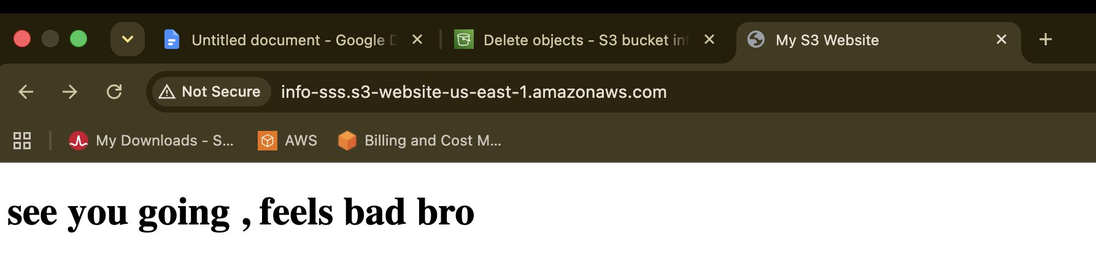
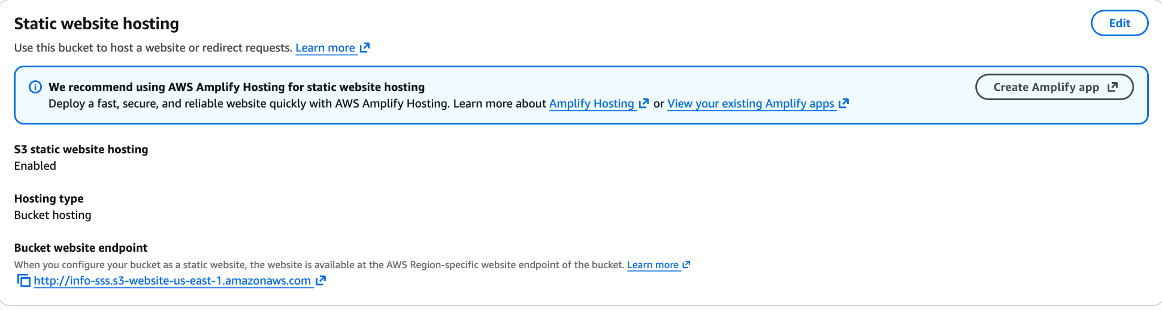

Enable cross-region replication on S3 buckets.
In another Region
S3 → General purpose buckets → Create bucket à Unique name
Enable Versioning on source bucket
Create the replication rule
S3 → Défault a Management a Find-Replication rules to Create replication rule
Give the rule a name à Choose à Apply to all objects in the bucket
Choose destination à Choose a bucket in this account
IAM role à Create new role à Save
Test réplication à Upload à
Check destination bucket à S3 → test-1342-replica → Objects
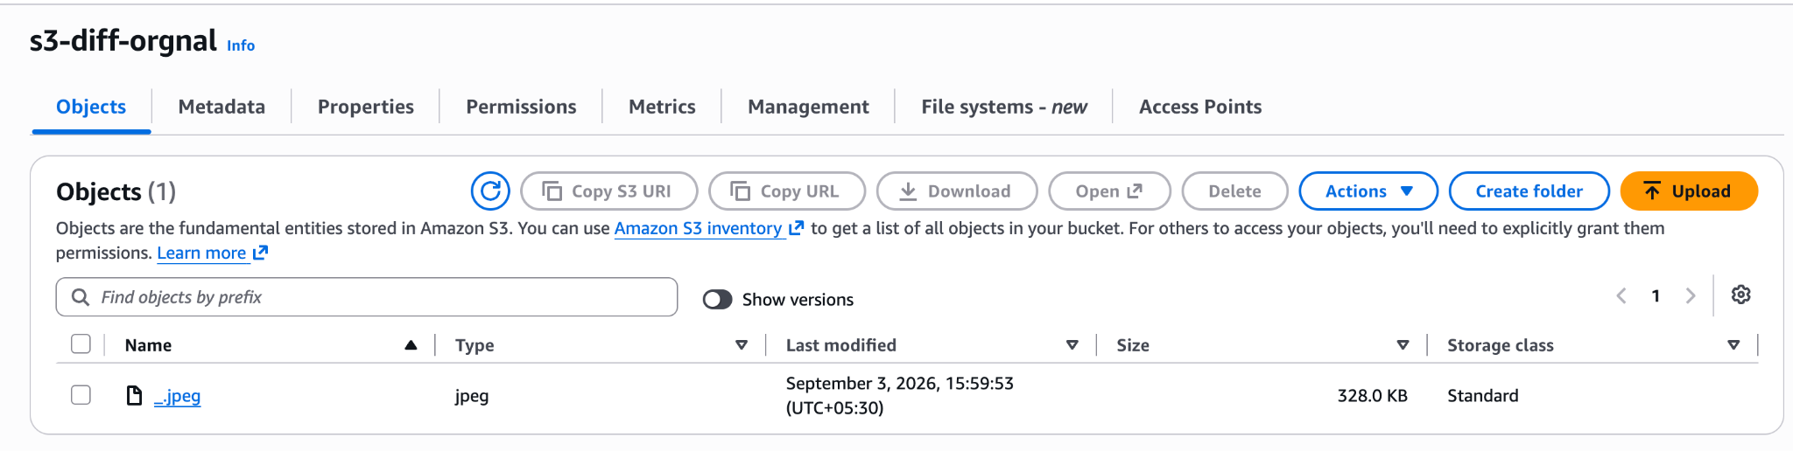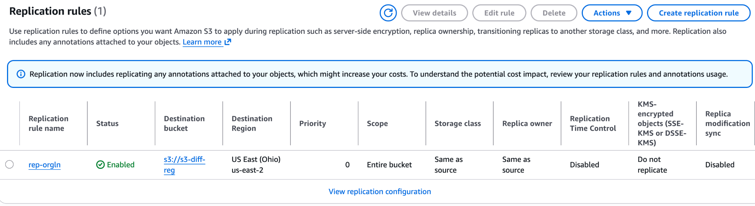
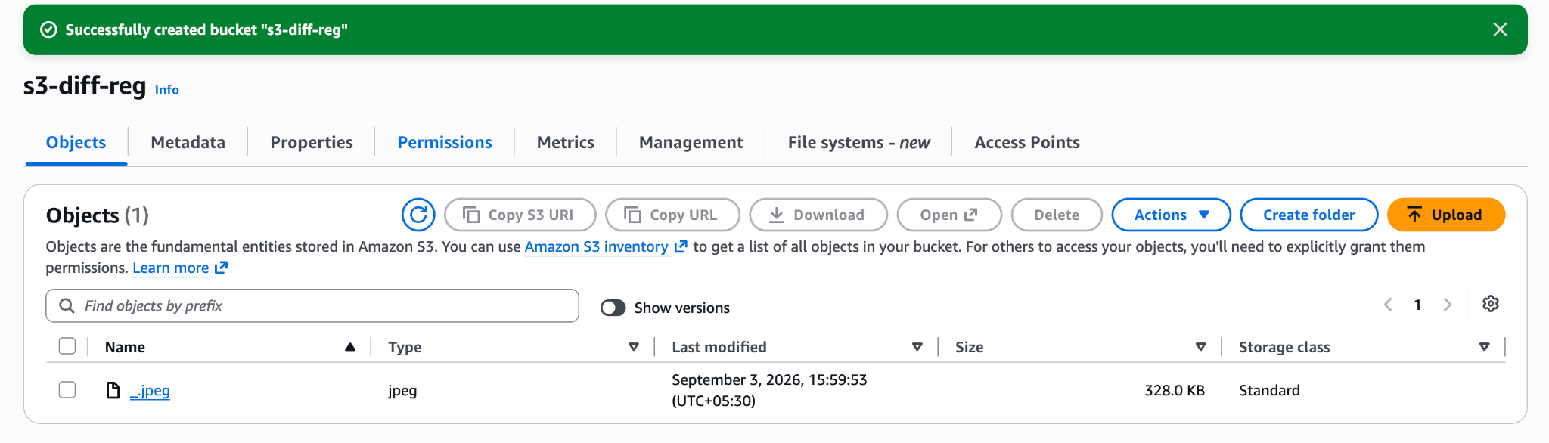

Configure a bucket policy so only the Admin user can see the objects of the S3 bucket.
Find the IAM user's ARN
IAM → Users → hhddhdh → Permissions add permissions Attach policies directly
AmazonS3ReadOnlyAccess
Next → Add permissions
Block public access
S3 → Buckets → info-sss→ Permissions
Block public access
Edit Enable: Block all public access
Replace the public bucket policy
info-sss→ Permissions Edit
{
"Version": "2012-10-17",
"Statement": [
{
"Sid": "AllowOnlyDevopsToReadAndListObjects",
"Effect": "Deny",
"Principal": "*",
"Action": [
"s3:GetObject",
"s3:ListBucket"
],
"Resource": [
"arn:aws:s3:::info-sss",
"arn:aws:s3:::info-sss/*"
],
"Condition": {
"StringNotLike": {
"aws:PrincipalArn": [
"arn:aws:iam::108457943052:user/Devops",
"arn:aws:iam::108457943052:root"
]
}
}
}
]
}

Sign in as your “hhddhdh” IAM user.
I can see all the lists in the S3 bucket
Test with another user
another IAM user, sign in as that user.
The non-Admin user should not be able to read the objects.
You may see: Access Denied
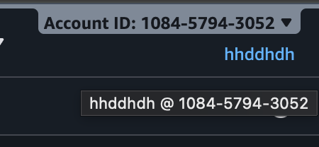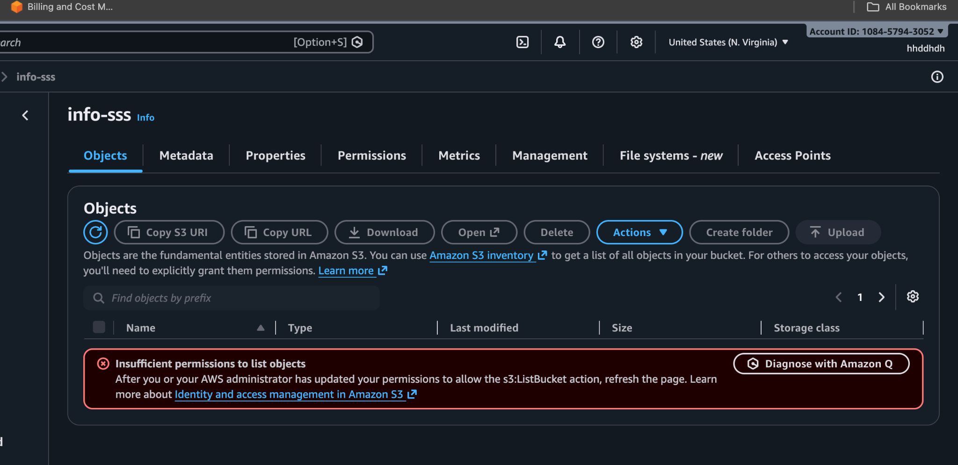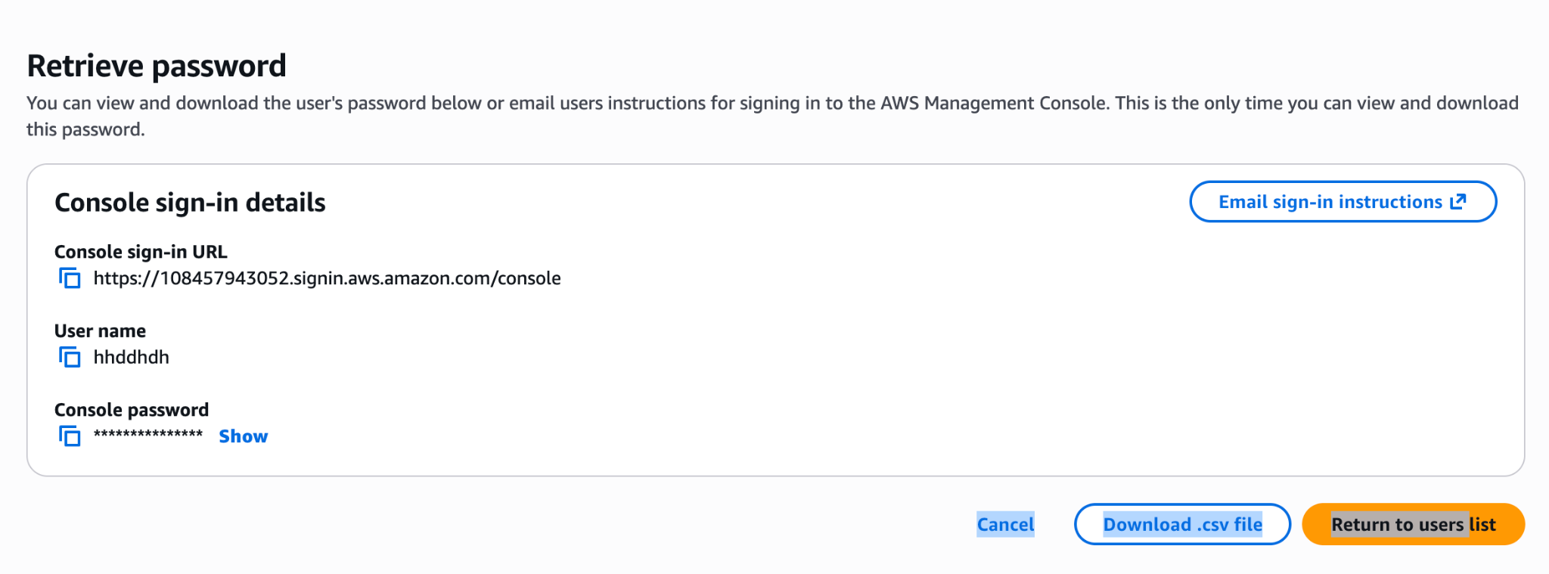
Set up lifecycle policies to automatically transition or delete objects based on specific criteria.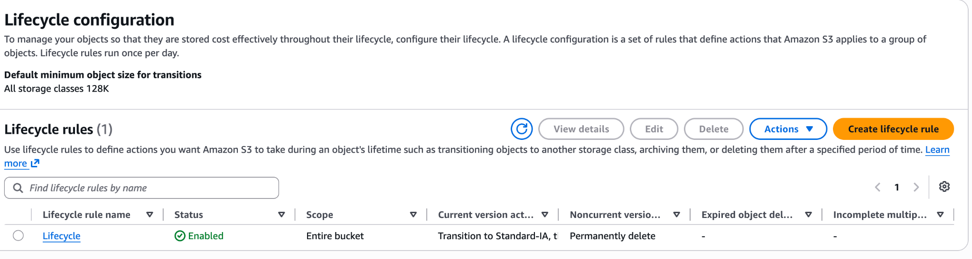
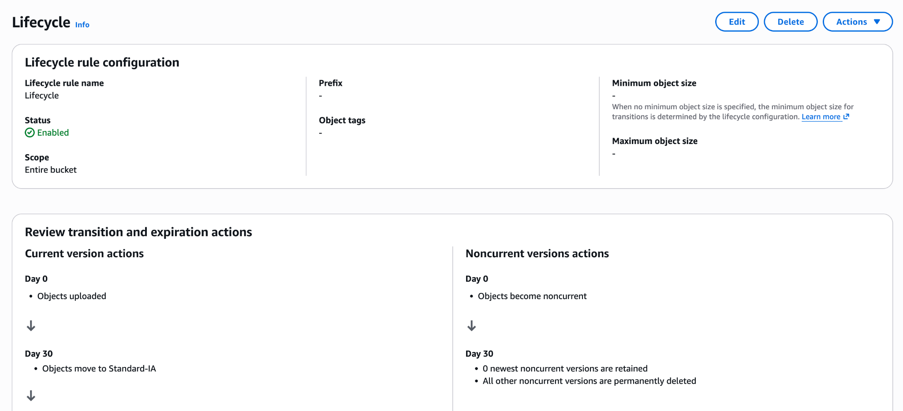
Step 1: Open Your Bucket's Management Settings

- Log into the AWS Management Console.

- Search for and open Amazon S3.

- In the bucket list, click on your bucket name: info-sss

- Select the Management tab near the top.

Step 2: Start the Lifecycle Rule Wizard

- Scroll down to the Lifecycle rules panel.

- Click the orange Create lifecycle rule button on the right.

Step 3: Define Rule Scope and Name

- Lifecycle rule name: Enter a descriptive name (e.g., archive-and-delete-policy).

- Choose a rule scope:

  - Select Apply to all objects in the bucket.

  - An acknowledgement checkbox will appear below: check "I acknowledge that this rule will apply to all objects in the bucket."

Step 4: Select Rule Actions

Under Lifecycle rule actions, tick the following checkboxes:

- Check: Move current versions of objects between storage classes

- Check: Expire current versions of objects
(Leave non-current version options unchecked if versioning is disabled on this bucket).

Step 5: Define Storage Transitions and Expiration Timeline

- First Transition:
  - Under Transition current versions of objects between storage classes, click Add transition.
  - In the dropdown, choose Standard-IA.
  - Under Days after object creation, enter 30.

- Second Transition:

  - Click Add transition again.

  - In the second dropdown, choose Glacier Flexible Retrieval (formerly Glacier).

  - Under Days after object creation, enter 90.

- Expiration (Deletion):

  - Under Expire current versions of objects, enter 365 in the Days after object creation box.

Step 6: Review and Save

- Scroll to the bottom of the page and review the visual timeline preview shown in the console.

- Click Create rule.
4.The rule will now show as Enabled under the Management tab, and AWS will automatically handle the transitions and deletions daily at midnight UTC.

Push some objects to S3 using the AWS CLI.
Grant the IAM user permission to upload to the destination bucket:
- Open the AWS Management Console and navigate to IAM > Users.
- Select your user (S3-swap).
- In the Permissions tab, click Add permissions > Create inline policy.
- Switch to the JSON editor and paste the policy:
{
"Version": "2012-10-17",
"Statement": [
{
"Effect": "Allow",
"Action": [
"s3:PutObject",
"s3:GetObject",
"s3:ListBucket"
],
"Resource": [
"arn:aws:s3:::info-sss",
"arn:aws:s3:::info-sss/*"
]
}
]
}
Use this command for file uploading post creation of policy
aws s3 cp upload-1 s3://info-sss/upload-1/
This is to see if the file is uploaded or not from cli
aws s3 ls s3://info-sss/upload-1/
Write a Bash script to create an S3 bucket.
In IAM
Edit
Create the Inline
{
"Version": "2012-10-17",
"Statement": [
{
"Sid": "AllowS3BucketCreationAndConfig",
"Effect": "Allow",
"Action": [
"s3:CreateBucket",
"s3:PutEncryptionConfiguration",
"s3:PutEncryptionConfiguration"
],
"Resource": "arn:aws:s3:::*"
}
]
}
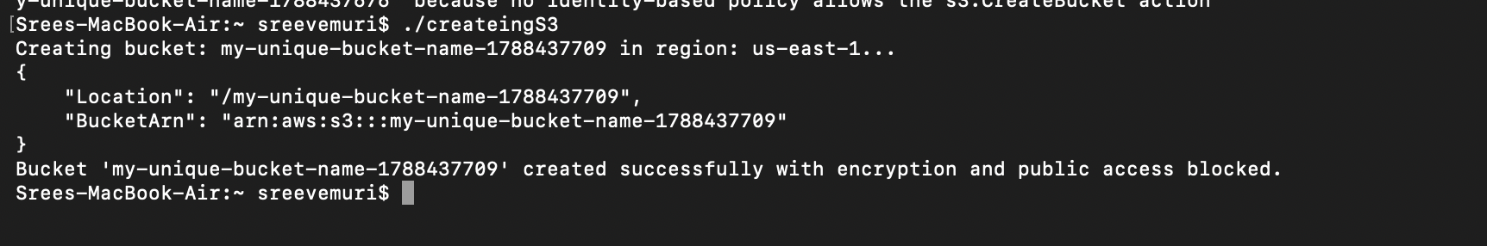
Upload a 1 GB file to S3 using the CLI.
df -h = Look at the available space for your main filesystem
dd if=/dev/zero of=large-file-1GB.bin bs=1M count=1024 = to make 1 gb file
ls -lh large-file-1GB.bin
du -h large-file-1GB.bin

Make sure AWS CLI is working
aws s3 ls s3://info-sss/
Upload the 1 GB file
aws s3 cp large-file-1GB.bin s3://info-sss/
The command is:
aws à AWS CLI s3 à S3 service cp à Copy/upload large-file-1GB.bin à Local 1 GB file s3://info-sss/ à Your S3 bucket

Verify the upload
aws s3 ls s3://df -h = Look at the available space for your main filesystem
dd if=/dev/zero of=large-file-1GB.bin bs=1M count=1024 = to make 1 gb file
ls -lh large-file-1GB.bin
du -h large-file-1GB.bin

Make sure AWS CLI is working
aws s3 ls s3://info-sss/
Upload the 1 GB file
aws s3 cp large-file-1GB.bin s3://info-sss/
The command is:
aws à AWS CLI s3 à S3 service cp à Copy/upload large-file-1GB.bin à Local 1 GB file s3://info-sss/ à Your S3 bucket

Verify the upload
aws s3 ls s3://info-sss/

17:30:18 37 cli-test.txt

15:37:23 53261 error.html.html

15:35:58 53261 error.html.txt

17:50:05 1073741824 large-file-1GB.bin

Clean up the 1 GB
aws s3 rm s3://info-sss/large-file-1GB.bin
aws s3 ls s3://info-sss/

delete your local file:
rm large-file-1GB.bin

17:30:18 37 cli-test.txt

15:37:23 53261 error.html.html

15:35:58 53261 error.html.txt

17:50:05 1073741824 large-file-1GB.bin

Clean up the 1 GB
aws s3 rm s3://info-sss/large-file-1GB.bin
aws s3 ls s3://info-sss/

delete your local file:
rm large-file-1GB.bin

